Aidan Glickman

Two Approaches to Border Growth in Avalon Hill’s Civilization

The board game Civilization by publisher Avalon Hill is played on a game board that features the approximate territory held by the Roman empire at the height of their powers. The map is split up in to 149 territories, each with a maximum occupancy value. In this paper, both a mechanistic and empirical approach will be employed to find the maximum number of territories that can be held by a player after n turns.

Source Text

The following text was provided as rules for border growth and movement in the game:

“In the game, your population would grow from just a single token (representing some number of people), to multiple tokens, by a pretty simple rule: If a space had one token in it, it would get another token in it at the start of a turn. If the space had two or more tokens in it, it would get two additional tokens at the start of a turn. Then, all of your pieces could move from whatever territory they started in to an adjacent territory each turn. Finally, each province had a limit on the number of tokens that it could support, as indicated by the number in the circle for each province. After movement, if the population of a territory was above that number, then the population would drop down to that number. Then, a new turn would happen.”

Using these rules, we can construct both a mechanistic and an empirical model to find the maximum number of territories after n turns.

A Mechanistic Approach

To get an idea of the number of territories one can hold after n turns, we can make several observations and assumptions about the game to arrive at a figure. On the basest level, we can begin by making some high-level observations about the game and the game board.

Firstly, a count will reveal that there are 149 territories on the board. Secondly, by using a list of all of the connections between territories, we can find that each territory has an average of about 4 connections. To find an average of the maximum territorial population, we can simply add up all of the maximums and then divide by 149, which gets us a figure of about 2 population per territory. Because of this figure, we can essentially disregard the clause in the rules relating to a case where “the space ha[s] two or more pieces on it,” and assume that each territory which is occupied will have 1 population at the end of each turn, and 2 at the beginning of each turn.

As a broader generalization of the board, we can examine what would occur if we used a 12 x 12 grid, as an average of 4 connections would imply that each territory is approximately a square with other territories on every side and a 12 x 12 grid would include 144 squares, the closest perfect square to 149.

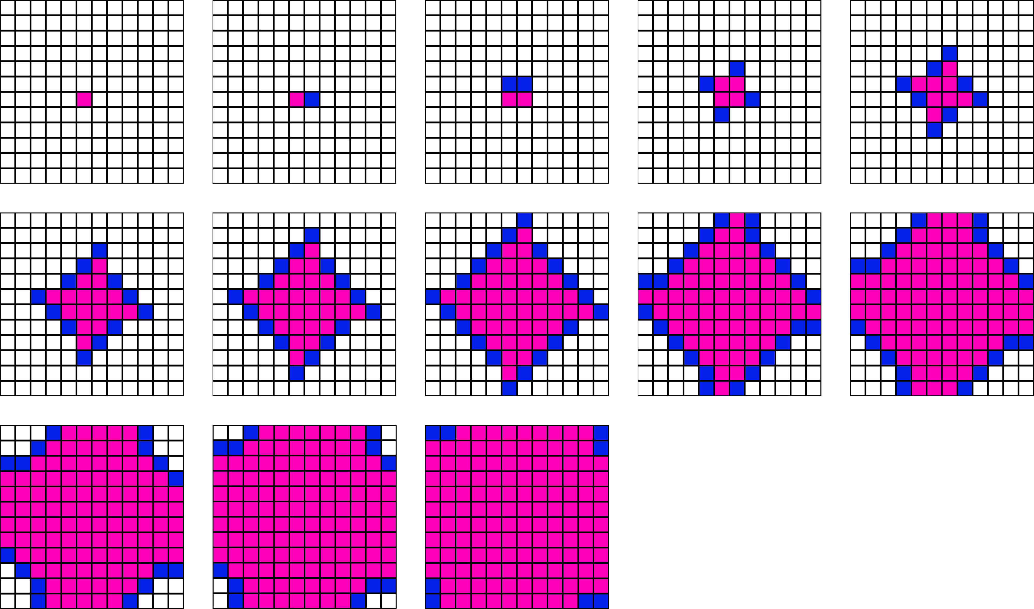
1 2 4 8 16 28 44 64 88 108 124 136 144
Figure 1: Progression Through the Mechanistic Model

Figure 1 visualizes the progression through our simplified board, using the most logical method for expansion of just keeping to the center as much as possible. This yields the board being filled in 13 turns, with a progression of powers of 2 for the first 5, before slowing down as the board becomes more saturated.

This mechanistic model gives a rough idea of a possible progression if every territory was the same, based on their average values on the actual board. This yields the dataset displayed in Figure 1 as the expected number of territories held on each turn.

Analysis of the Mechanistic Approach

This mechanistic model is useful for a rough value for a much more normalized version of Civilization, but in its assumptions and generalizations loses the nuance of the situation. In this model the rate of change of the number of territories is linked solely to the saturation of the board, whereas in a true simulation there would be an even greater difference as the player’s borders reach different regions of the map which may have different densities of territories.

An Empirical Approach

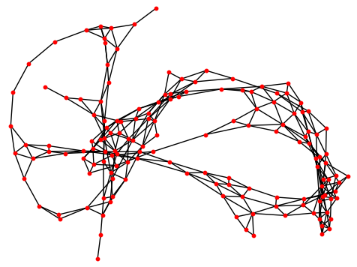
For the empirical approach, we can simply run a simulation of the game to find the best outcomes. To do this, the game board can be simplified to a graph, with each border between two nations represented by a vertex between two nodes representing the nations. This yields a graph that can then be easily traversed to create our data set.
Figure 2: Board Connection Graph

Figure 2 shows a graphical depiction of the generated graph. Although none of the positional integrity is kept, we can see how this graph mirrors the board, with some very dense areas with many connections and different territories, such as the area of Italy on the board, and other, more sparse areas with fewer connections, for example in the fertile crescent.

Using this graph, we can now run our simulation. The simulation is pretty simple. For each spot that is occupied at the beginning of a turn, the simulation will look for empty spaces next to it for one of the tiles to move to. This simulation generates a dataset of the expected number of territories controlled by a player from every possible starting point for each turn up until turn 21, by which point every starting point can control every territory.
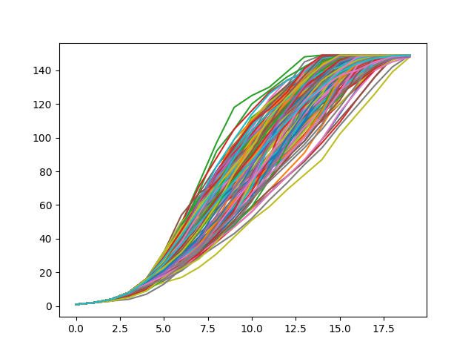
Figure 3: Spaces Occupied Over n Moves from Various Starting Points

To answer the question of what the maximum number of spaces occupied after n turns is, there are 2 approaches that can be taken. Either we can analyze only the most optimal path to get to 149 territories and look at the number of territories at each step, or we can look at the maximum number of territories after n turns across every run of the simulation.

1 2 4 8 16 32 47 59 75 91 106 118 128 143 149
Figure 4: Progression Starting in Byzantium

If we look at the most optimal path to get to 149, we find that among the starting points that get to 149 in 15 moves (of which there are 5,) we find that starting at Byzantium has the quickest growth early on. Figure 4 details the number of territories held throughout the first 15 moves. Interestingly, the first 6 turns have exact exponential growth with increasing powers of 2. This is because for the first couple of turns, the population available to occupy territories doubles every turn, and every single excess population is still able to move to a new territory, as the board is not yet well saturated.

1 2 4 8 16 32 51 69 88 105 118 126 134 143 149
Figure 5: Maximum Values at Each Turn

The other dataset we can look at is the maximum value at each turn, which is shown in Figure 5. Due to the issue of saturation addressed above, the first 6 turns are the same, growing exponentially. After this point, the different starting points which are good candidates (i.e. those which are in heavily saturated areas as to not hinder growth at the start,) begin to diverge, yielding some paths which are more saturated early on but peter out later on as they run out of easily reachable spaces.

The first possibility of looking at a progression from Byzantium (Figure 4) provides us with insight on what the progression over a singular game looks like, whereas the maximum values (Figure 5) show us the values that can be attained if games are played to specifically target the maximum value after any n turns.

Analysis of the Empirical Approach

The simulation employed here is generally strong, as it emulates the conditions set in the rules, with a full representation of the board. The only possible weakness to this method is the procedure used to decide where to move from a filled position. The simulation simply looks for any open territory, and if there are multiple options the simulation picks which to advance to randomly. This could be improved by implementing a heuristic to evaluate the state of the board (possibly using a combination of both the number of territories conquered and the population that is on the border and able to mobilize quickly) and using an intelligent search algorithm such as A* to find better solutions. Another issue with how the simulation carries out is that populations that are in territories with no unoccupied territories immediately connected to them simply stay stagnant instead of moving towards borders to at least provide the possibility of them eventually being useful.

Conclusion

To sum up our results, both our mechanistic and empirical models are surprisingly alike, with the mechanistic approach reaching full saturation after 13 turns, and the empirical reaching saturation after 15. In terms of the number of territories from turn to turn, the maximum simulation values start out larger, but slow down as the mechanistic speeds up. This is due to the empirical model going from a region of the board with extremely high territorial density to regions of lower density, while the density stays constant in the mechanistic model.

The empirical model is probably more accurate, as it does not have to make large generalizations and essentially simulates the actual rules. Because of this, we will conclude that the datasets in Figures 4,5 are the best representations, depending on whether the question is referring to the number of territories in the best possible play of the game, or simply the greatest number of territories in any possible game at turn n for a given value of n.

